# RESPIRE-X

# Circuit Documentation

## Summary

What is Asthma?

Asthma is a chronic lung condition that makes breathing difficult. It causes inflammation and narrowing of the airways, leading to symptoms like wheezing, coughing, chest tightness, and shortness of breath. Asthma attacks can be triggered by irritants in the environment or even exercise.

Introducing the Asthma Monitor:

This device is designed to help people with asthma manage their condition by monitoring key environmental factors and body vitals. It acts like a personal weather station for your lungs!

**Component List**

How it Works!!

Sensors:

It tracks temperature and humidity, which can affect asthma symptoms.

An air quality sensor detects pollutants that can trigger asthma attacks.

Body Monitors:

It measures your heart rate, which can increase during an asthma episode.

It measures your blood oxygen level, which can drop during an asthma attack.

Display:

An easy-to-read screen shows all this information in one place.

**Benefits for Asthma Patients:**

Early Warning System: By monitoring these factors, you can identify potential triggers before they cause an asthma attack.

Proactive Management: You can take steps to avoid triggers or use your medication preventively.

Peace of Mind: Knowing your key health stats can give you more control over your asthma and reduce anxiety

## Wiring Details

### Arduino UNO

* 3.3V to MAX30102 VIN
* 5V to DHT11 VDD, MQ 135 VCC, LCD VCC, and Potentiometer VCC
* GND to common ground net
* A0 to MQ 135 A0
* A4 (SCL) to LCD SCL and MAX30102 SCL
* A5 (SDA) to LCD SDA and MAX30102 SDA
* D2 to DHT11 DATA
* D8 to MQ 135 D0

### MQ 135 Sensor

* VCC to 5V from Arduino
* GND to common ground net
* D0 to Arduino D8
* A0 to Arduino A0

### MAX30102 Heart Rate and Oxygen Sensor

* VIN to 3.3V from Arduino
* GND to common ground net
* SCL to Arduino A5
* SDA to Arduino A4

### DHT11 Humidity and Temperature Sensor

* VDD to 5V from Arduino
* DATA to Arduino D2
* GND to common ground net

### Potentiometer

* VCC to 5V from Arduino
* GND to common ground net
* Output (middle terminal) not connected in this configuration

### LCD screen 16x2 I2C

* VCC to 5V from Arduino
* GND to common ground net
* SCL to Arduino A5
* SDA to Arduino A4

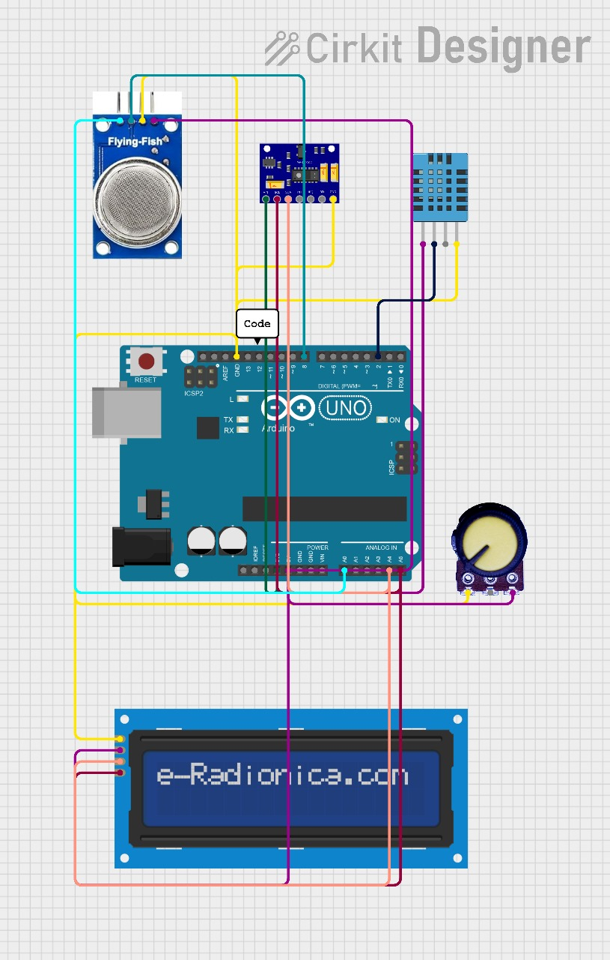

## Documented Code

// Include necessary libraries  
#include <Wire.h>  
#include <LiquidCrystal_I2C.h>  
#include <DHT.h>  
#include <MAX30105.h>  
  
// Define constants  
#define DHT_PIN 2 // DHT11 pin  
#define MQ135_PIN A0 // MQ135 pin  
#define POT_PIN A1 // Potentiometer pin (not used in this code)  
#define MAX30102_PIN 3 // MAX30102 pin (not used in this code)  
  
// Initialize LCD display  
LiquidCrystal_I2C lcd(0x27, 20, 4); // Set LCD address, columns, and rows  
  
// Initialize DHT11  
DHT dht(DHT_PIN, DHT11);  
  
// Initialize MAX30102  
MAX30105 max30102;  
  
void setup() {  
 // Initialize serial communication  
 Serial.begin(9600);  
  
 // Initialize LCD display  
 lcd.init();  
 lcd.backlight();  
  
 // Initialize DHT11  
 dht.begin();  
  
 // Initialize MAX30102  
 max30102.begin();  
}  
  
void loop() {  
 // Read temperature and humidity from DHT11  
 float temperature = dht.readTemperature();  
 float humidity = dht.readHumidity();  
  
 // Read air quality from MQ135  
 int airQuality = analogRead(MQ135_PIN);  
 airQuality = map(airQuality, 0, 1023, 0, 100);  
  
 // Read heart rate and oxygen saturation from MAX30102  
 int heartRate = max30102.getHeartRate();  
 int oxygenSaturation = max30102.getOxygenSaturation();  
  
 // Read potentiometer value (not used in this code)  
 // int potValue = analogRead(POT_PIN);  
 // potValue = map(potValue, 0, 1023, 0, 100);  
  
 // Display values on LCD  
 lcd.setCursor(0, 0);  
 lcd.print("Temp: ");  
 lcd.print(temperature);  
 lcd.print(" C");  
  
 lcd.setCursor(0, 1);  
 lcd.print("Humidity: ");  
 lcd.print(humidity);  
 lcd.print(" %");  
  
 lcd.setCursor(0, 2);  
 lcd.print("Air Quality: ");  
 lcd.print(airQuality);  
 lcd.print(" %");  
  
 lcd.setCursor(0, 3);  
 lcd.print("Heart Rate: ");  
 lcd.print(heartRate);  
 lcd.print(" bpm");  
  
 // The following lines are commented out because the potentiometer is not used in this code  
 // lcd.setCursor(1, 1);  
 // lcd.print("Potentiometer: ");  
 // lcd.print(potValue);  
 // lcd.print(" %");  
  
 delay(1000);  
}

Code Description:

This code is for an asthma monitor. It reads data from various sensors and displays it on a small screen.

Sensors:

* Temperature and humidity sensor (DHT11)

* Air quality sensor (MQ135)

* (Not used in this version) Heart rate and oxygen saturation sensor (MAX30102)

Display: LCD screen

The code:

1. Sets up communication and initializes the sensors and screen.

2. In a loop, it reads data from the sensors:

* Temperature and humidity

* Air quality

* (Not used in this version) Heart rate and oxygen saturation

3. Shows the readings on the LCD screen.